Amadeus

Data Mining Exercise – solved in Python

# First exercise: Give number of lines in bookings & searches table

The number of lines in bookings is 10000010

The number of lines in searches is 20390198

# Second exercise: Top 10 arrival airports in 2013 by number of passengers

# Results:

#

# arr_port pax

# LHR 88809

# MCO 70930

# LAX 70530

# LAS 69630

# JFK 66270

# CDG 64490

# BKK 59460

# MIA 58150

# SFO 58000

# DXB 55590

# Third exercise: Plot the monthly number of searches for flights arriving at Málaga, Madrid or Barcelona.

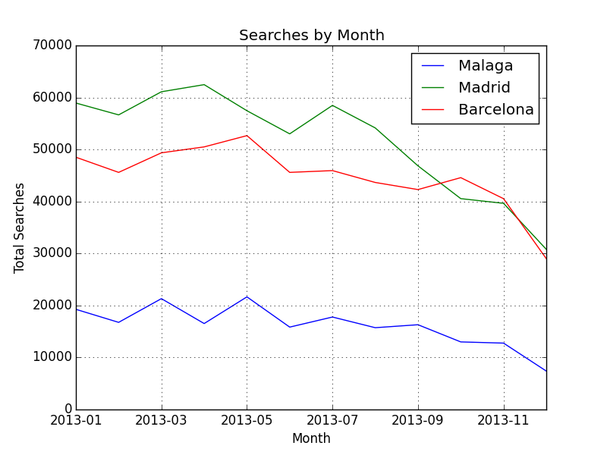

# Bonus exercise 1

Please see table searches_booked.csv, it’s only run on a small sample of the data since I didn’t have the time to run it through the whole data set.

# Bonus exercise 2

Please refer to the bonus2web folder.

Matching criteria:

A search is booked if:

1. All its segments has a corresponding booking record with matched Dep & Arr port, boarding date

2. The search date is on the same day of the booking date

3. If a booking is matched, it will not be reused for further matching

Assumptions:

1. Identical rows in searches are from same end-user

2. Identical rows in bookings are from different end-users